Lot 71

Contour lines for the lot, at 0.5 metre intervals

Calculation of points on line A-G, B-H, C-J and B-C, H-G, J-H

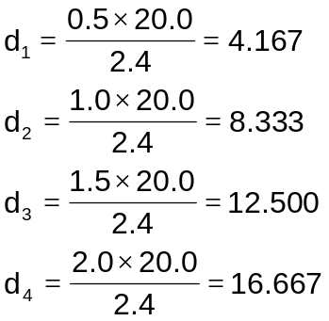  A-F | 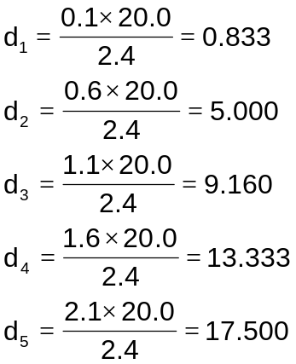  B-E | 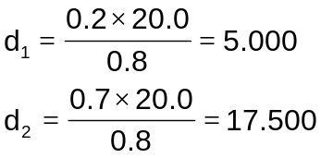  C-D
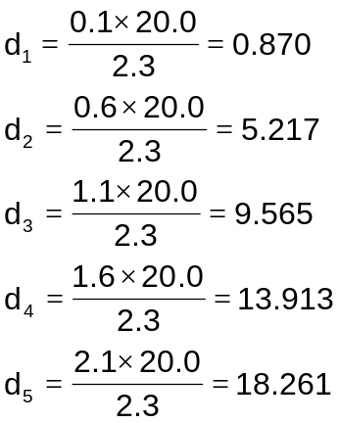  F-G | 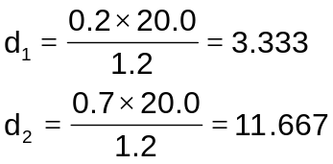  E-H | 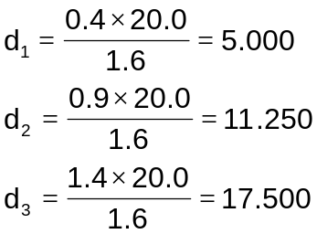  D-J
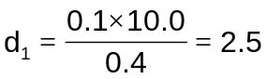  B-C | 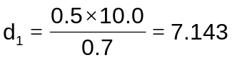  H-G | 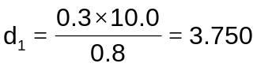  J-H

